**Abstract**

The usage of RFID tags is at an all-time high with their applications in a vast variety of fields, especially in Internet of Things domain. The main reason for this is the pricing of the components and ease of setting up and usage. It is an easy to comprehend mechanism for everyone and the RFID tags are compact, making them a hassle-free option for travel. The RFID scanner also has a compact factor compared to other scanning devices.

The main aim of this paper is to consider ranging and locating an RFID tag in a certain area with centimeter-level accuracy. It also aims at computing 3D localization of the tag. To locate the tag, we utilize the 3 or more distances between sensor and reference points and then this data is combined to obtain the 3D location of the tag. This would be a huge step forward in the security, inventory and gesture-based systems as it is possible to track the tag real-time. The main challenge is the lack of computation power in the sensors and the power consumption for the required amount of computational power. The proposed bypass to the limitations is to move the sensor data to a main processing unit with sufficient power and computational capacity. This would make it compatible with existing sensors and sensor systems.

1. **Introduction**

The result of positionally locating a tag can be implemented in a lot of different fields like IoT position-based applications, as well as human-machine gestural interfaces, virtual and augmented reality, domotics, medical monitoring and rehabilitation, flexible robotics, security access control, assets monitoring etc. A system which can identify minute movements is needed to achieve this. Along with that, a cost efficient, battery independent or low power consuming sensor system is preferred. The thought of adding localization capability to existing systems is intriguing and it is possible. The infrastructure needed to do so are already available in the form of cost-efficient tags and capability to identify unique IDs.

The location of tags can be determined by the use of Radio Frequency signals [1], sound waves [2][3], magnetic fields [4] or optical signals [5]. To determine the position of the tags, require computation of the distance between reference points, the remote sensor. The 3D location calculation requires a minimum of 3 distance measurements. Various techniques can be used to achieve the result, one of the methods is based on Received Signal Strength Indicator (RSSI) [6]. RSSI is simple to implement but it has some limitations and the accuracy of this method is only in meters. To improve on the accuracy of the system would increase the complexity and the cost of the system.

The more common system utilizes Ultrasonic waves. This has a higher reported accuracy than a Radio frequency system. The determination of time-of-flight is much easier in the Ultrasonic signals. The acoustic systems can use Time of Arrival (ToA), Time Difference of Arrival (TDoA) [2] or Angle of Arrival (AoA) [7] to obtain a location with a reported accuracy on the order of centimeters. Biggest drawback of acoustic propagation system is that it consumes way more energy than the RF systems. This leads to bigger and heavier batteries which in turn results in limited computational power due to the space constraint in the system proposed. An RFID-bases system which uses a passive Wireless Identification and Sensing Platform (WISP) platform utilizes custom passive tags which contains acoustic tone detector. A spy WISP is used to track the timing and traffic between the reader and the tag and synchronize to determine the relative distance.

Cross-correlation is an algorithm with top accuracy levels, but the downside is that it requires loads of power to execute. The miniature RFID tags have a lot of size constraints and thus this is a drawback. The approach proposed is to offload the computation to an external CPU to reduce the load on the sensor. This way, we can have the benefits of two technologies and techniques. We are utilizing the high accuracy of ultrasound ranging with the use of cross-correlation computations but in an RFID-based architecture. This leads to the tag to still remain light weight and low power consumption.

1. **Motivation**

Cross-correlation method has had superior accuracy generally and also good acoustical noise immunity. The acoustical signals are correctly sampled and converted from analog to digital. The resulting samples array R is cross-correlated with the digital reference signal S which is stored in the memory. Considering that R and S are finite length array containing real values and length NR and NS respectively. The mth entry c(m) of cross-correlation C=R*S is given by

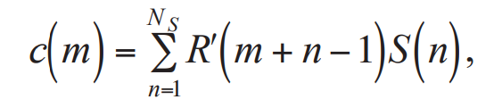

Here, m = (1, 2… NR+Ns-1) is the displacement or lag.

R’ is the zero padded R, which means that Ns-1 zeros were added at the beginning and the end of R before cross-correlating.

The maximum of cross-correlation C indicates the point in time where R and S are best aligned. The cross-correlation peak lag is proportional to the Time-of-Flight (ToF) and to the distance between ultrasound emitter and receiver by assuming the known sound of speed. However as discussed already, this technique involves a lot of processing and this leads to it being a power-hungry algorithm. There are several off-the-shelf microprocessors capable of the computations necessary but they require power in tens of milliwatts which is impossible to provide with battery-less or small battery powered devices. Thus, the ranging information obtained from the ultrasonic signal is detected and then transmitted to an external CPU through RFID standard data channel. This allows us to compute accurate cross-correlation array.

1. **Ranging Technique and System Architecture**
2. The ranging technique

Some of the techniques and bypasses discussed in the above sections will be looked in detail here. The most important one is to exploit the cross-correlation technique without the sensor having to bear the burden of computation or power for the computation.

Moving the computation to the external CPU is achieved by a transducer placed at known coordinates which emits a broadcast sync signal through the RF radio transmitter and it also broadcasts an ultrasonic chirp.

Sensors which are in the radius will sense the RF sync signal and receive the ultrasound signal and sample it in the fixed receiving time window.

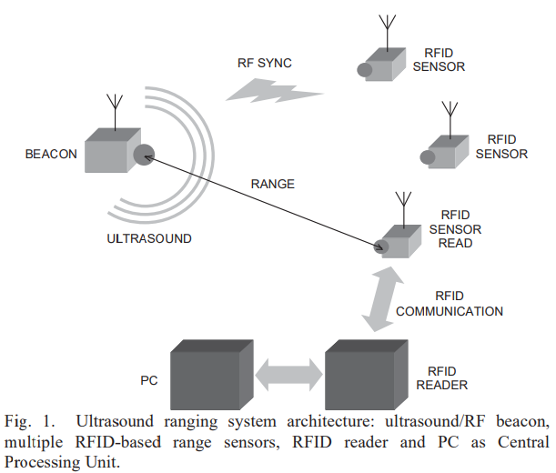

A RFID reader at any given instant can interrogate any one of the available sensors. The sensors send the sampled chirp along with the EPC (identity) to the reader. This is then sent to the external CPU which reconstructs the captured chirp and cross-correlates it to the existing chirp which gives us the delay and thus the range is calculated. The RFID protocol allows the reader to interrogate the RFID tags in its neighborhood only one at a time, and there is no limit to the number of RFID tags in a space region, other than the maximum number of possible EPCs used to code the identity of each tag.

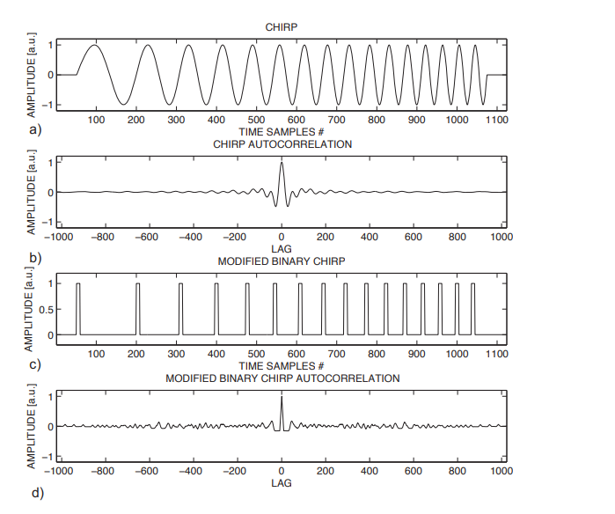

In brief, the ultrasound travels from the emitter to the sensor’s microphone where a suitable onboard circuit amplifies, filters and digitally squares the impinging ultrasonic signal. As a result, at the end of this chain, the impinging ultrasonic signal is converted into a sort of binary PWM signal, the modified binary signal (MBS), which saves bandwidth and energy when transmitted. A code running in the processing unit “restores” the PWM-like binary signal from the sequences of transition times received, and computes the cross-correlation with a previously stored copy of the emitted chirp.

1. System Architecture

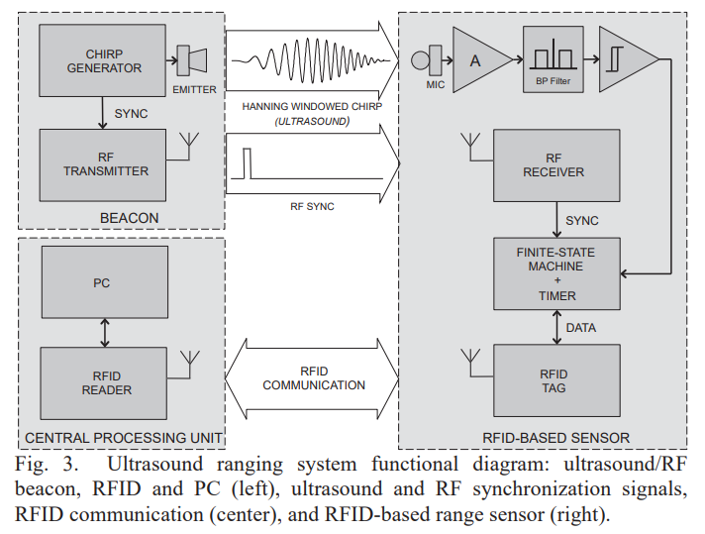

1. Ultrasound and RF Beacon

The beacon consists of a microcontroller, a DAC, a power amplifier, an acoustic emitter, and an RF transmitter. Multiple beacons are deployed [8][9] for 3D localization since multiple measurements are required. These beacons are each other synchronized when emitting the same chirp in a given sequence, or are independent, but emitting uncorrelated chirps to avoid signal collision.

1. Central Processing Unit

The central processing unit is made up of a standard RFID reader which can download timed data from the tags and that of a processing device. A microprocessor board is sufficient. The main job of the device is to read data from the RFID reader and restore the original MBS, cross-correlate it to the received MBS and display the ranging data.

1. Sources of ranging Uncertainty

Time of Flight or ToF in short and the ranging estimate both are affected by uncertainties. There is a not negligible time jitter present even after RF synchronization. Another uncertainty is caused at the receiver side. The onboard timer can have its own unavoidable drift inducing more uncertainty in the result. Other factors such as the read-write cycle and air turbulence can cause more inaccuracies.

1. Remarks

The main concern of the system is the detection of the true highest peak of ToF. There can be interference from other signals which might cause some smaller false peaks. To overcome this, we can calibrate the repetition time of the acoustic signal and if the echoes of the other sources are weak, we can assume that the first peak above a certain threshold is the actual correlation peak.

We can utilize a search method to identify the first cross-correlation peak which is above the noise threshold. The signal copies necessary for computing the cross-correlation don’t reside on the remote sensor: when needed, the emitted signal can be dynamically changed to cope with acoustical disturbances or collisions, and different codes can be assigned to different ultrasound emitters without any change in the sensor hardware or firmware.

1. **System Realization**

There are some choices that we need to make to utilize the off-the-shelf components successfully. The frequency bandwidth of the chirp should be higher than the commercial microphones so that there is minimal to no collision at all. A linear up-chirp in the bandwidth 15-40 kHz is employed. The sensor timer clock frequency is set to 1 MHz, so that the time resolution of the interrupt sampling is 1 μs. At this clock frequency, assuming the speed of sound in air 343 m/s, the space resolution is about 0.34 mm. The chirp signal is composed of 1024 samples at 192 kSamples/s with a duration of about 5.33 ms. An increased duration of the chirp improves the SNR of the cross-correlation, but at the expenses of both ranging rate and CPU computational effort.

1. Central Processing Unit

A dedicated processor or FPGA can also be used, but we are utilizing a PC here. The algorithms are written in MATLAB and they are executed to generate the signals and to store and analyze the data. Signals are emitted by the MOTU 828 mk3 board. However, the present prototype uses only two outputs of the board, one for the ultrasound emitter and the other for the RF transmitter of the beacon. FireWire is used to connect the PC. An M6E MICRO UHF RFID reader acquires the timer data from the tag.

1. Ultrasound and RF beacon

The ultrasound emitter employed is an HT 259, driven by a custom Class AB MOSFET power amplifier. Preliminary tests have shown that this specific model is able to emit sufficiently accurate chirp signals in the desired acoustic band. The transducer also has a reasonable low cost, in view of system mass production. The RF transmitter is the TX section of an RTX MID 3V transceiver, working at 433.92 MHz with binary ASK modulation scheme.

1. RFID-based remote sensor

The ultrasound circuit includes a miniature microphone FG6163, which is a micromachined condenser microphone in a cylindrical shape package, length and diameter 2.6 mm, weight 80 mg, and acoustical receiving window diameter 0.79 mm. The receiving acoustical window is small compared to the used wavelength range (about 8.6-22.9 mm in the 15-40 kHz range, with sound speed in air 343 m/s), ensuring a good approximation of a point-like omnidirectional receiver.

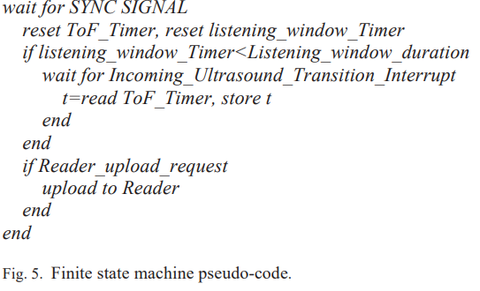

1. **Experimental Results**

With the experimental setup in place, the experimental results can be observed. The beacon emits a linear chirp from 15 to 40 kHz as expected. A calibration session estimated the time jitter of this operation being less than 1 μs, while the deterministic delay was 13.4 μs. The listening window was set to 12 ms, equivalent to a maximum range of about 4.11 m, assuming a speed of sound in air of 343 m/s.

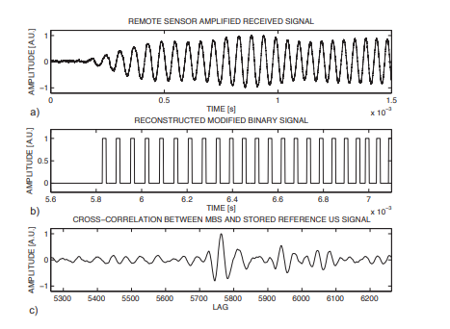

As for the accuracy and reliability, the lower bound for the time accuracy detection of the time delay is given by Cramer-Rao formula

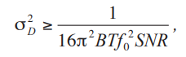

where BT is time-bandwidth product

f0 is the center frequency

SNR is the signal-to-noise ratio (SNR high enough to have no ambiguity in the peak detection)

In the present case, B = 25 kHz, T = 5.3 ms, f0 = 27.5 kHz, SNR = 25 dB, and σD 2 ≥ 1.31·10-15 s. assuming the sound velocity 343 m/s at 20 °C, the distance error lower bound results about 12 μm.

The experimental ranging results and the errors when the remote sensor is moved along a straight line is shown below

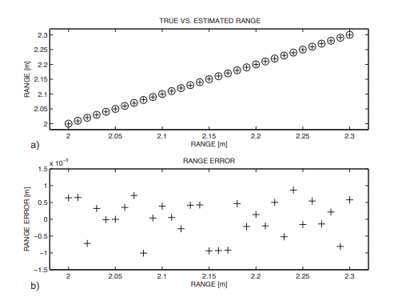

To determine the ranging performance in the worst condition, 30cm distance was measured. The line path starts from a point placed at 200cm and stops at distance of 230cm from the emitter. To avoid the faulty measurements the experiment is repeated 100 times, thus avoiding any abnormal readings. The cumulative error distribution of the ranging data is shown with cumulative error distribution of the data averaged over 100 ranging operations for each slider position.

The error is acceptable considering the system time sampling and the jitter limitations and the cumulative error distribution of the average data shows a better behavior.

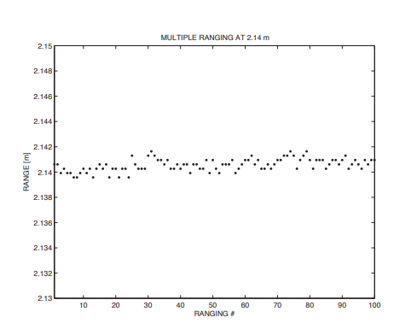

The average current used during the working was calculated to be 8mA. All the circuitry can be implemented using ultra low power technology and can be made into a single system-on-chip (SoC) which can be wirelessly powered using the regular power harvesting techniques making this much more power efficient. The ranging rate of 1 Hz was a bottleneck but the focus was to add ranging capability to the RFID tags and accurately at that. System bottleneck is not the main concern for this research and it can be improved greatly in the future with better technology.

1. **Conclusion**

The technique presented aimed to provide measurements for ranging of a RFID tag using cross-correlation technique with minimal computation and power to the processing unit. At the same time, it also aimed to provide ranging accuracy in the order of millimeters, which is much smaller than the employed ultrasound wavelength. The major drawback is that the cross-correlation algorithm is computation intensive which cannot be done on a battery less or small batter operated remote sensor. The proposed technique hence outsourced the computation to an external processing unit with sufficient power supply. Reasonably low ultrasound frequencies have been used, in order to use commercial and low-cost ultrasound components, still obtaining millimeters ranging accuracy. Experimental results show a ranging accuracy of about ±1.2 mm within a range of 2.30m.

As this technique runs on a standard PC notebook, it is compatible with most systems, it is also compatible with the existing RFID systems. The proposed technique allows for the technique to be implemented on a smaller SoC improving the efficiency of the technique further. The applications of this method can be seen in various fields like IoT smart devices, gestural interfaces, real time tracking of human movements and gaming consoles. Newer technology and coding algorithms will improve the performance further as well as an alternate method to bypass the RF sync signal.

**References**

[1] L. M. Ni, Y. Liu, Y. C. Lau, and A. P. Patil, “LANDMARC: Indoor Location Sensing Using Active RFID,” Springer Wirel. Networks, vol. 10, no. 6, pp. 701–710, 2004.

[2] N. B. Priyantha, A. Chakraborty, and H. Balakrishnan, “The Cricket location-support system,” in Proceedings of the 6th annual international conference on Mobile computing and networking - MobiCom ’00, 2000, pp. 32–43.

[3] F. Ionescu, R. Carotenuto, and R. Urbani, “3D Localization and Tracking of Objects Using Miniature Microphones,” Wirel. Sens. Netw., vol. 3, no. 5, pp. 147–157, 2011.

[4] D. D. Arumugam, J. D. Griffin, and D. D. Stancil, “Experimental demonstration of complex image theory and application to position measurement,” IEEE Antennas Wirel. Propag. Lett., vol. 10, pp. 282–285, 2011.

[5] A. P. Sample, C. MacOmber, L. T. Jiang, and J. R. Smith, “Optical localization of passive UHF RFID tags with integrated LEDs,” 2012 IEEE Int. Conf. RFID, RFID 2012, pp. 116–123, 2012.

[6] J. Torres-solis, T. H. Falk, and T. Chau, “A review of indoor localization technologies: towards navigational assistance for topographical disorientation,” Ambient Intell., pp. 51–84, 2010.

[7] M. Saad, C. J. Bleakley, T. Ballal, and S. Dobson, “High Accuracy Reference-free Ultrasonic Location Estimation,” IEEE Trans. Instrum. Meas., vol. 61, no. 6, pp. 1561–1570, 2012.

[8] R. Carotenuto and P. Tripodi, “Touchless 3D gestural interface using coded ultrasounds,” in IEEE International Ultrasonics Symposium, IUS, 2012, pp. 146–149.

[9] R. Carotenuto, G. Caliano, and A. S. Savoia, “3D locating system for Augmented Reality glasses using coded ultrasound,” in IEEE International Ultrasonics Symposium, IUS, 2013, pp. 441–444.